CJA eVoucher
Attorney User Manual

Release 4.3

November 2015
Contents
Nota Bene: Edit before using! 1
Introduction 2
Panel Management 2
Voucher & Authorization Request Submission 2
Browser Compatibility 2
Court Appointment 2
Accessing the CJA eVoucher Program 3
Home Page 4
Navigating in the CJA eVoucher Program 4
Customizing the Home Page 6
My Profile 7
Changing My Profile Username and Password 9
Attorney Info 10
Billing Info 11
12
Holding Period 13
Continuing Legal Education 14
Appointment’s List 16
View Representation 17
CJA 20 Voucher Process Overview 18
Creating the CJA 20 Voucher 18
Entering Services 20
Entering Expenses 22
Claim Status 25
Documents 26
Signing and Submitting to Court 27
CJA 20 Quick Review Panel 30
Reports and Case Management 31
Defendant Detailed Budget Report 32
Defendant Summary Report 33
Creating a CJA 21 Voucher 34
Submitting an Authorization Request for Expert Services 41
Creating an Authorizations for Transcripts (AUTH 24) 45
Creating a CJA 24 Voucher 47
Creating a Travel Voucher 51
Creating a CJA 26 Voucher 54

Nota Bene: Edit before using!

We are distributing this manual in Word format to make it easier for you to customize the content to follow your local rules and CJA rules. You may wish to include information about some of the following topics:

Do you wish to include contact information for CJA administrators to the attorneys? Web site link?

Are you using the CM/ECF link in eVoucher?

Are attorneys allowed to edit their own profile and billing information? Enter Holding Periods?

Do attorneys still file any CJA-related documents in CM/ECF?

What is your policy about interim payments?

How will your site handle the CJA-24 Auth and the CJA-24 voucher? Will court reporters be involved as Experts? Will the attorney create the CJA-24?

Will the panel attorneys use the CLE-tracking feature in eVoucher?

Will the attorneys be doing the Travel Authorization provided in eVoucher?

Will you be using the email proposed appointments available in eVoucher? How will attorneys be notified of appointments?

Can you provide more specific information about what kinds of documents you wish the attorney to attach for each document type?

Introduction

The CJA eVoucher System is a web-based solution for submission, monitoring and management of all Criminal Justice ACT (CJA) functions. The eVoucher program will allow for:

- On-line authorization requests by attorneys for service providers.
- On-line voucher completion by the service provider or by the attorney acting for the service provider.
- On-line voucher review and submission by the attorney.
- On-line submission to the court.

Unless the court has indicated otherwise, attorneys are generally required to create and submit vouchers for their service providers. The program includes the following modules:

Panel Management

- Allows attorneys to manage their own account information including address, phone, firm associations and applicable CLE credits.
- Allows for submission of holding periods or a specific amount of time taken off for medical leave, vacation, etc.

Voucher & Authorization Request Submission

- Authorization requests by attorneys for expert services
- Requests by attorneys for interim payment
- Upload supporting documents to vouchers or authorization requests
- Reports for attorneys to take an active part in monitoring costs
- Automatic e-mail notification to attorney of approval or rejection of vouchers and authorization requests

Browser Compatibility

- Windows: Internet Explorer 8 or newer are approved.
- Apple Macintosh: Safari 5.1 or newer is approved.
- Chrome, Firefox and other browsers may not be used with CJA.

Court Appointment

When an appointment is made, an email will automatically be generated by the program, and sent to the appointed attorney. The email will confirm the appointment and provide a link to the CJA eVoucher program.

Some Courts may send a proposed email to the Attorney, awaiting acceptance of a specific case.

Accessing the CJA eVoucher Program

Your court will provide information on how to access eVoucher. It is suggested that you bookmark it for easier access.
Log in using your Username and Password you were provided, and click Log In.

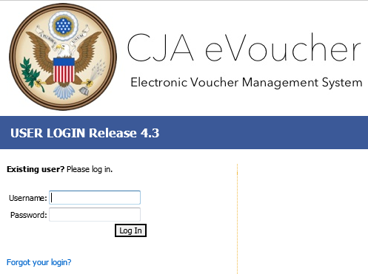

Users will be required to change their passwords within 30 days of the first time they log in to eVoucher. Passwords must be at least eight characters in length and contain:

- One lower-case character
- One upper-case character
- One number
- One special character
Users are required to change their passwords every 180 days.

If you forget your username or password, click the Forgot your Login? hyperlink.
Enter your Username or Email address, and click Recover Logon to retrieve your information.

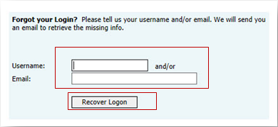

Home Page

Your home page provides access to all of your appointments and vouchers.
Security prohibits you from viewing information for any other attorney. Likewise, no one else will have access to your information.
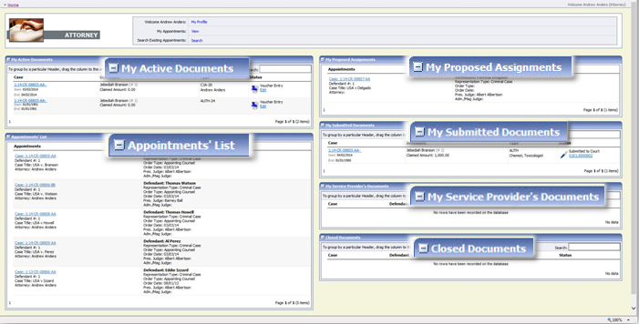

Folder Descriptions
My Active Documents | Contains documents that you are currently working on or have been submitted to you by an expert service provider. These documents are waiting for you to take action.
Appointments’ List | Quick reference to all your appointments
My Proposed Assignments | Cases will appear in this folder if an appointment has been proposed to you and you have not accepted or rejected the appointment.
My Submitted Documents | Contains vouchers for yourself, or for your service provider, which have been submitted to the court for payment. Documents submitted to the court requesting expert services or interim payments will also appear in this folder.
My Service Provider’s Documents | Contains all the vouchers for your service providers.  This will include:  - Vouchers in progress by the experts  - Vouchers submitted to the attorney for approval and submission to the court  - Vouchers signed off by the attorney and submitted to the court for payment
Closed Documents | Contains documents that have been paid or have been approved by the court.  Closed documents will only be displayed for open cases. Closed documents are displayed until they are archived and/or for 60-90 days after the appointment is terminated. They are still accessible through the appointment page.

Navigating in the CJA eVoucher Program

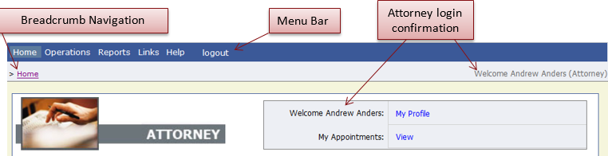

Menu Bar Items
Home | The eVoucher home page
Operations | Allows you to search for specific appointments
Reports | Selected reports you may run on your appointments
Links | Hyperlinks to CJA resources: forms, guides, publications, etc.
Help | Provides:  - Another link to your Profile  - “Contact Us” email  Privacy Notice
Logout | Logs user off the eVoucher program

Customizing the Home Page

Customizing your home page allows you to alter the manner in which your information is displayed in the folders.

Expanding/Collapsing Folders: Click the plus sign to expand a folder. Click the minus sign to collapse a folder.

Moving Folders

Place your mouse pointer on the top edge of the folder you wish to relocate.
Step
1
A crosshair icon will appear.

Step
2
Drag the folder to the new location and release the mouse.

Sorting: Click the column heading (e.g., Case, Description, Type) to sort in either ascending or descending order.

Resizing of Column
Step
1
Along the folder headings (e.g. case, defendant, type, etc.), move your cursor to the line between the
columns until a double arrow appears.

Step
2
Drag the line in the desired direction to enlarge or reduce the column size.

Note: The folder size does not increase; therefore, some columns may move off the screen.

Customizing the Home Page (continued)

Group by Column Heading: You may sort all the information within a folder by grouping documents by the column heading. All folders displaying the Group Header bar may be sorted in this manner.

Step
1
Click the header for the column you wish to group.

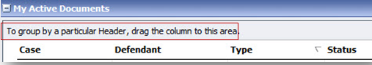
Step
2
Hold the cursor and drag the header to the Group by: Header bar.

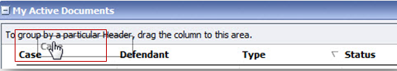

Step
3
Release the cursor and all the information in that folder will be grouped and sorted by that selection.

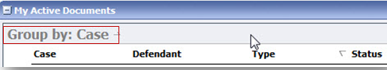

My Profile

In the My Profile section, the attorney may:

- Change password (Login Info section).
- Edit contact information, phone, e-mail, physical address (Attorney Info section).
- Update social security number (SSN) or employee identification numbers (EIN) and any firm affiliation (Billing Info section). Any changes in SSN after the first login, must be done through the court.
- Add a time period in which you will be out of office (Holding Period).
- Document any CLE attendance (Continuing Legal Education section).

Click the My Profile link from either the Home screen or the Help menu bar to open the My Profile page.
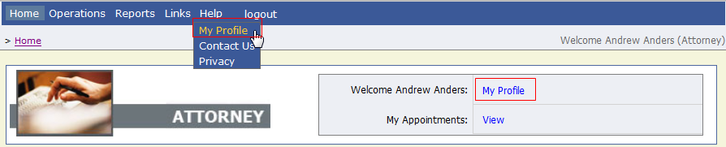

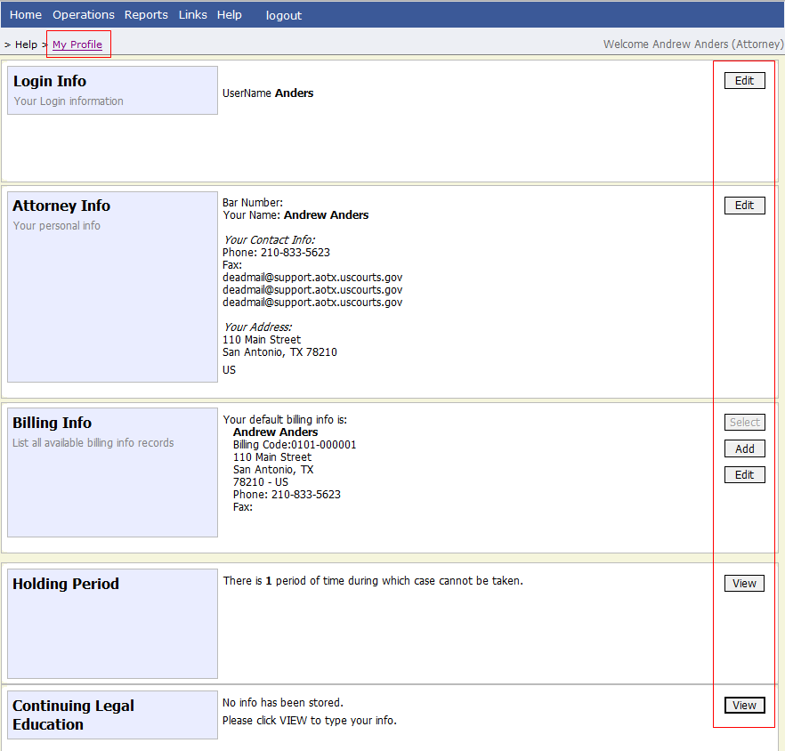

Changing My Profile Username and Password
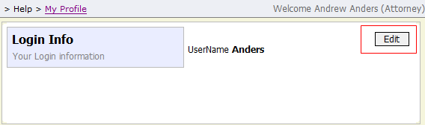
Under the Login Info section, click Edit to change your Password.
Step
1
To change your Username, type the new Username and click change. It will show “The Username has been changed.”
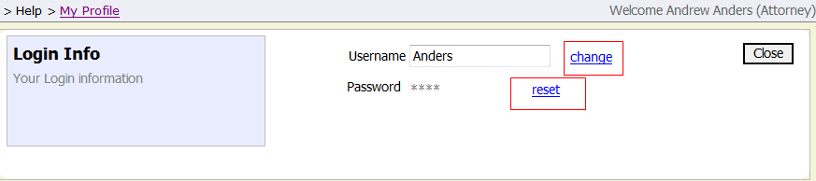
To reset your password, click reset.
Step
3
Step
2

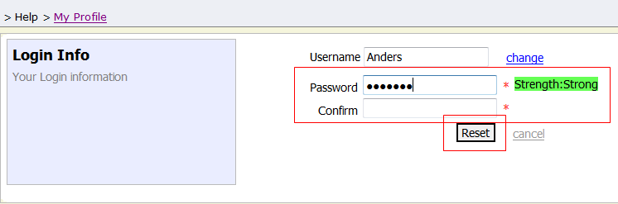
Click Reset to save.
Step5
Step4
Type the new password and retype it in the Confirm field.

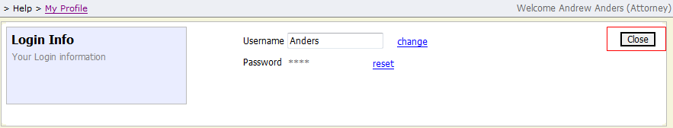
Step
6
Click Close to exit the Login Info section.

Attorney Info

Under the Attorney Info section, click Edit to access your personal information.
Step 1
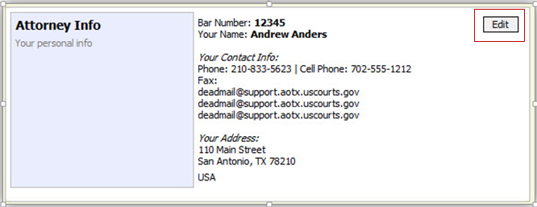

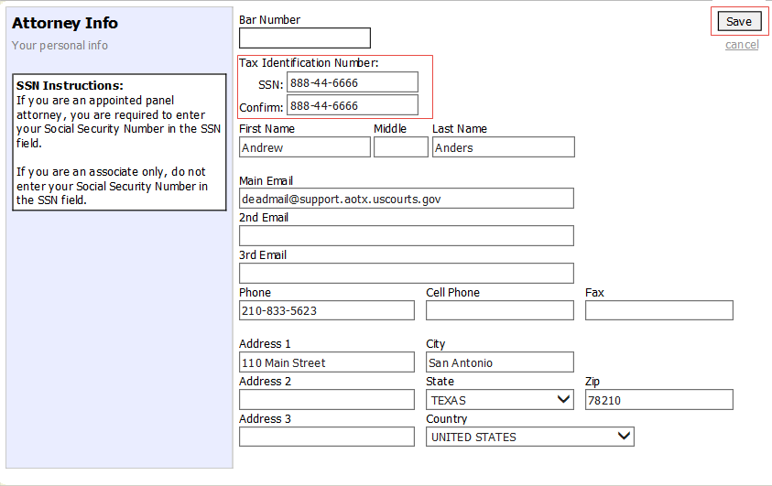
Click Save.
Make any necessary changes.
Step
3
Step
2

Note:
- Each attorney (except Associates) must enter his or her social security number into the user profile or they will not be paid.
- The Country field will automatically populate UNITED STATES unless otherwise indicated.
- You may list as many as three email addresses. Notifications from eVoucher will be sent to all email addresses.

Billing Info
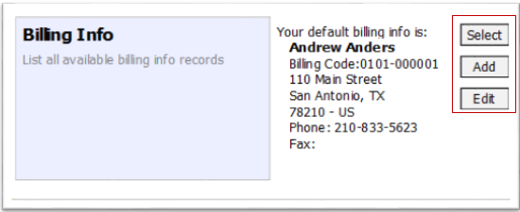
Under the Billing Info section, click Add if no billing information is available.
Step
1

Click Edit if you wish to change the information already entered.
Step
2

Note:
- You must have billing information entered before any payments can be made.
- The SSN/EIN is used when reporting income to the IRS.
- You may use the Copy Address from Profile checkbox if your billing address is the same as your Attorney Info address.

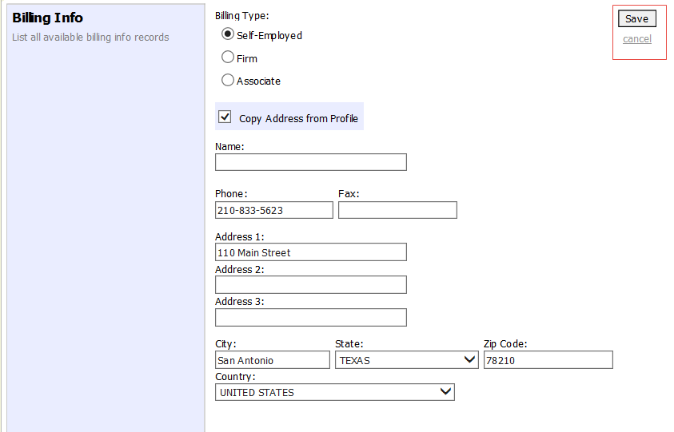
Step
3

Make any necessary changes and click Save.

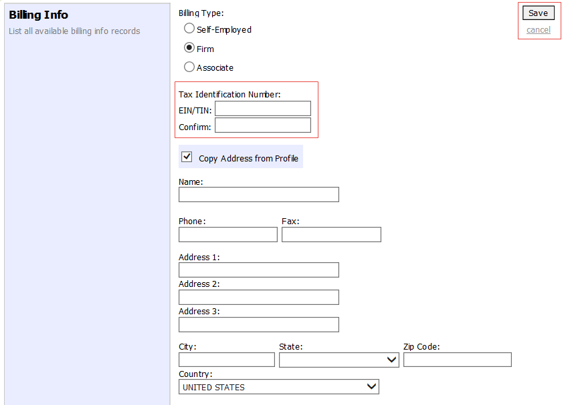
If applicable, add Billing Info for a firm or an associate by clicking the corresponding radio button.
Step
4
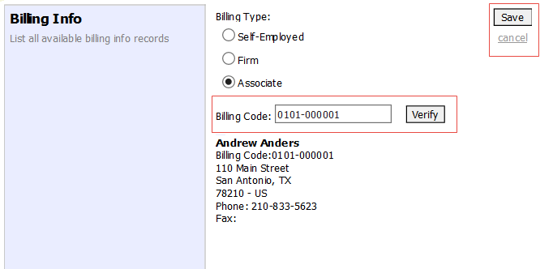

Note:
- Attorneys with a pre-existing agreements must enter the firm’s EIN and name (required).
- Associates do not need to enter a social security number, but they will need to ender the billing code of the attorney to be paid.

Holding Period

Holding periods can be used for medical leave, vacation, etc. During this time you will not be given a new assignment.
Step
1

In the Holding Period section, click View.

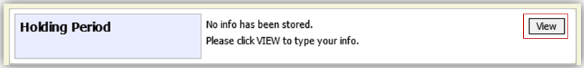

Step
2
Click Add.

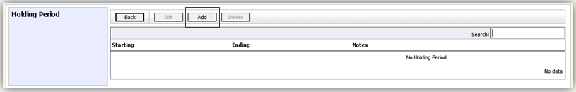

Enter the Starting Date and Ending Date, along with any applicable Notes.
Step
3

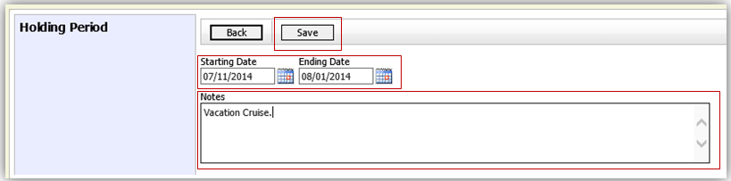

Click Save.
Step
4

Continuing Legal Education

Step
1
Under the Continuing Legal Education section, click View to access your CLE information.

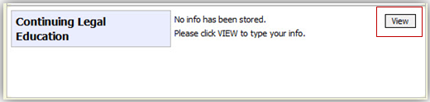
Step
2
To add CLE information, click Add.

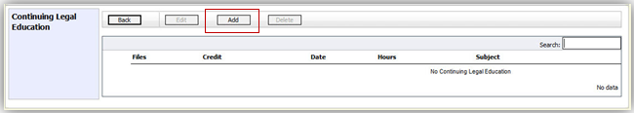

Step
3
Click the Credit drop-down menu to select CLE categories.

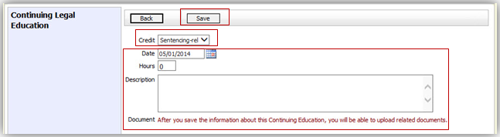

Enter the Date, the number of Hours, and a Description.
Step
5
Step
4

Click Save.

Note: After information is saved, you’ll be able to upload related PDF documents.

Continuing Legal Education (cont’d)

Click Browse to upload and attach a PDF document.
Step
6

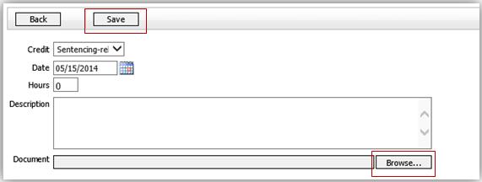
Click Save.
Step
7

All entries will be appear in the grid and can be accessed, edited, or deleted by selecting the entry and choosing an action button.

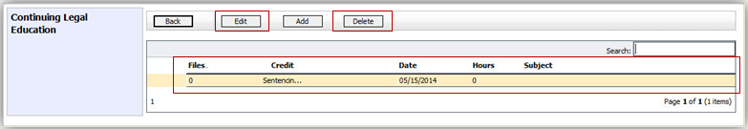

Appointments’ List

Locate the Appointments section under the Appointments’ List on your home page.
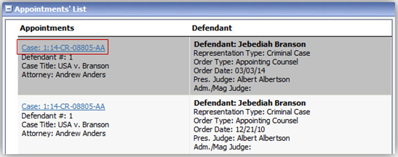
Click the case number hyperlink to open the Appointments page.
Step
1

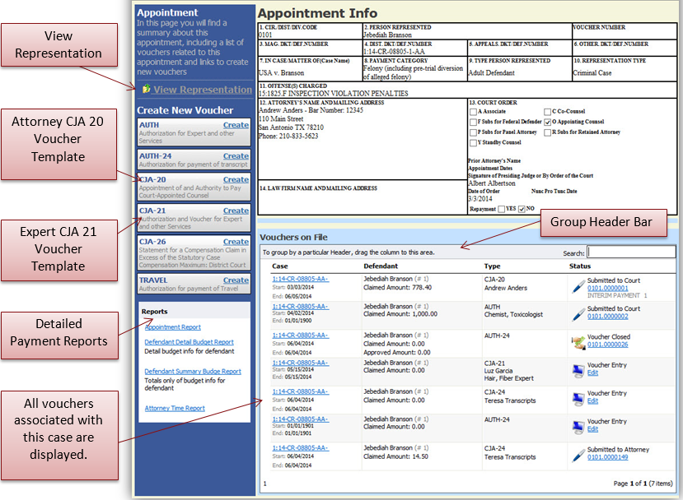

Group Header Bar

View Representation

The View Representation information will display:
- Default excess fee limit
- Presiding judge
- Magistrate judge
- Co-counsel
- Previous counsel

From the Appointment page, click View Representation.
Step
2

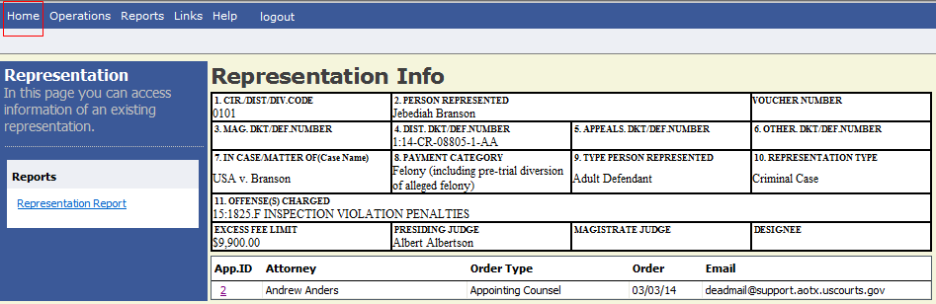

Step
3
Click Home on the menu bar at the top of the page.

CJA 20 Voucher Process Overview

Attorney enters time/expenses and submits voucher
Court processes voucher for payment
Court approves or rejects voucher
Court CJA Unit audits voucher

Creating the CJA 20 Voucher

The court creates the appointment. The attorney will initiate the CJA 20 voucher.
Note:
All voucher types and documents function primarily the same.

From the Appointment page, click Create from the CJA-20 Voucher template.
The voucher opens to the Basic Info page which displays the information in the paper voucher format.
Step
1
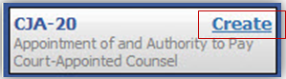

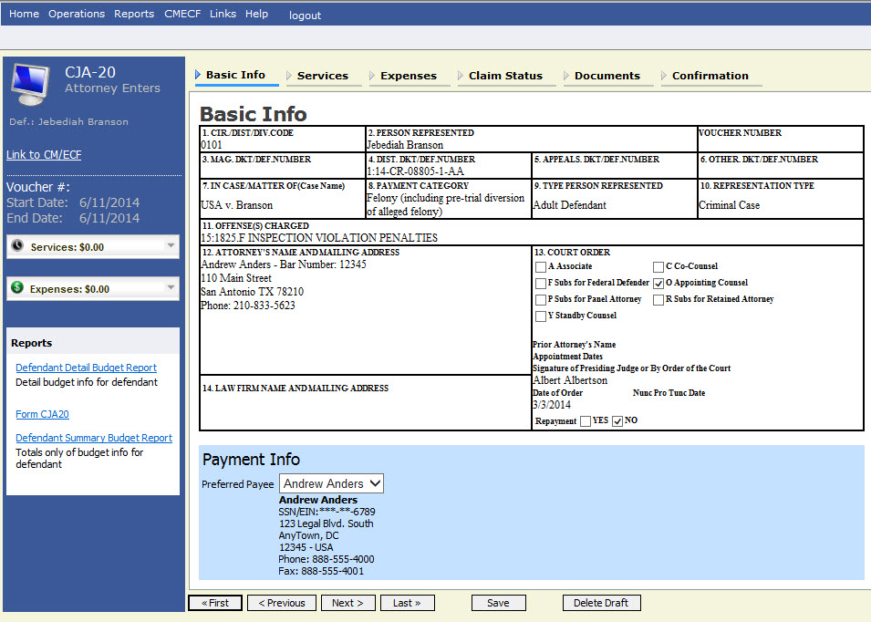
Creating the CJA 20 Voucher (cont’d)

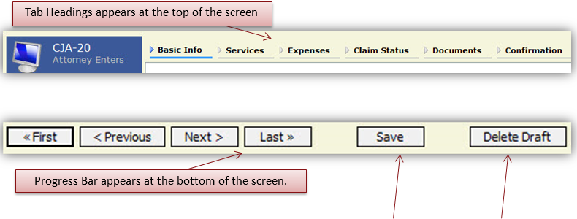

Notes:
- The user should save any entries made to a voucher often to avoid data loss.
- At any time prior to submitting the voucher, the user may delete the voucher by clicking Delete Draft.
- The user may navigate using the tab headings or progress bar.

Entering Services

Line-item time entries should be entered on the Services tab.
Both In-Court and Out-of-Court time should be recorded on this screen.

Click the Services tab or click Next, located on the progress bar.
Step
2
Note:
There is NOT AN AUTOSAVE function on this program. You must click SAVE periodically to save your work.

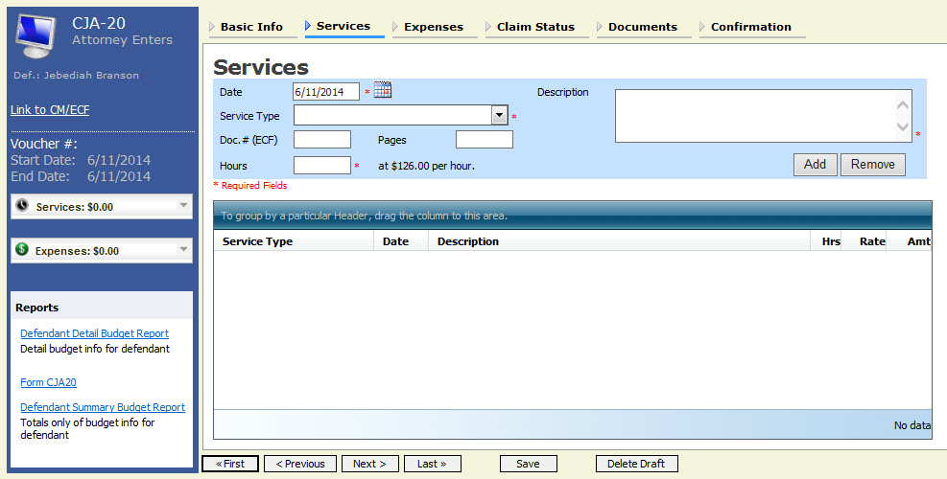

Enter the date of the service. The default date is always the current date. You may type in the date or click the calendar icon to select a date from the pop-up calendar.
Step
3
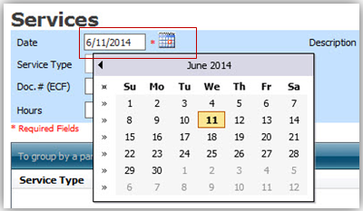

Services (cont’d)
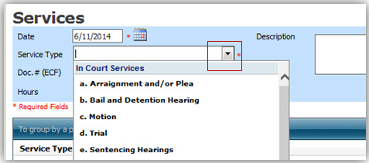
From the Service Type drop-down menu, select the service type.
Step
4
Note:
You may add dates in any order. You can sort in chronological order at any time.

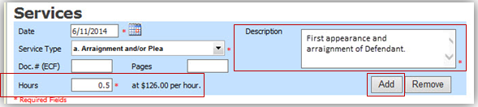
Enter a description.

Step
6
Enter hours of service in tenths of an hour.

Step
5

Note:
- You may add time in any order.
- Click an entry to edit.
Step
7
Click ADD.

The entry will be added to the voucher and appear at the bottom of the Service Type section.

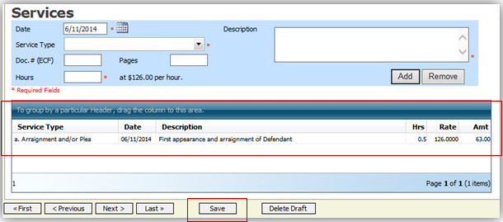
Click Save.
Step
9
Step
8
Click the Date header. This will sort services according to date.

Entering Expenses
Click the Expenses tab or click Next.
Step
1

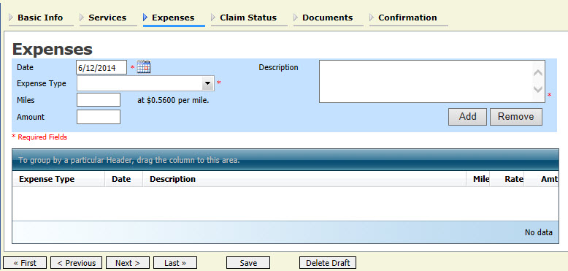

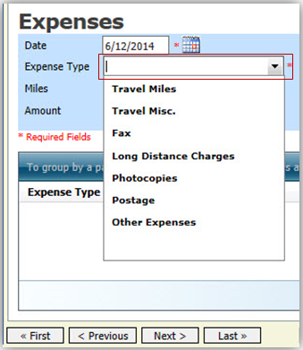
From the Expense Type drop-down menu, select the applicable expense.
Step
2
Entering Expenses (cont’d)
If Travel Miles is selected, enter the round trip mileage.
Step
3

Enter a description in the Description field.

Step
4

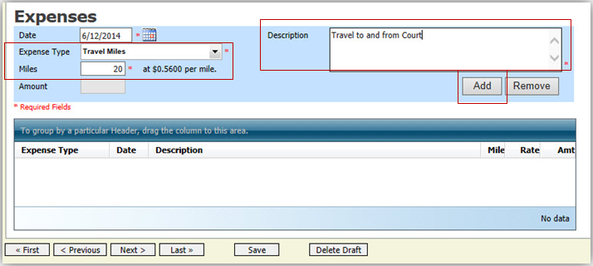
Step
5
Click Add.

The entry will be added to the voucher and will appear at the bottom of the Expense Type section.

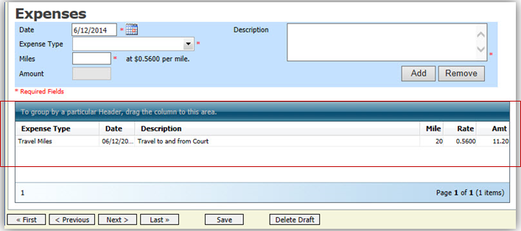

Entering Expenses (cont’d)

Notes:
- If photocopies or fax expenses are chosen, indicate the number of pages, and the rate charged per page.
- Remember to click Add after each entry.
- Click an entry to edit.

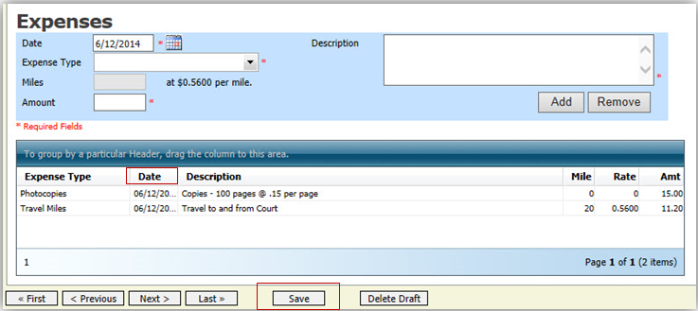
Step
6
Click the Date column header. This will sort expenses according to date.

Click Save.
Step
7

Claim Status

Once you begin entering data on the Service and/or Expenses tab, you may receive what looks like an error message:
The message will be removed when you complete the Claim Status section with correct start and end dates which include all service and expenses dates for the voucher.
Step
1
Click the Claim Status tab or click Next located on the progress bar.

Enter the start date from the services or expenses entries, whichever date is earliest. If need be, go back to the Expense and Service sections, and click the Date header to sort showing the earliest date of services.
Step
2

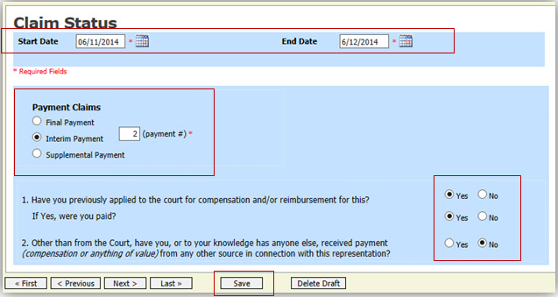
Step
3
Indicate payment type.

Note:
- Final Payment is requested after all services have been completed.
- Interim Payment allows for payment throughout the appointment, but each court’s practice may differ. If using this type of payment, indicate the number of interim payments.
- After the Final Payment has been submitted, Supplemental Payment may be requested due to a missed or forgotten receipt.
Answer all the questions regarding previous payments in this case.
Step
4

Step
5
Click Save.

Documents

Attorneys (as well as the court) may attach documents.
Attach any documentation that supports the voucher, i.e., travel or other expense receipts, orders from the court.
Note:
All documents must be submitted in PDF format, and must be 10 MB or less.
To add an attachment, click Browse to locate your file.
Step
1

Add a description of the attachment.
Step
2

Step
3
Click Upload.

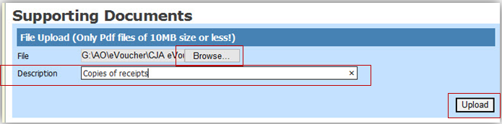

The attachment and description is added to the voucher and appears in the bottom of the Description section.

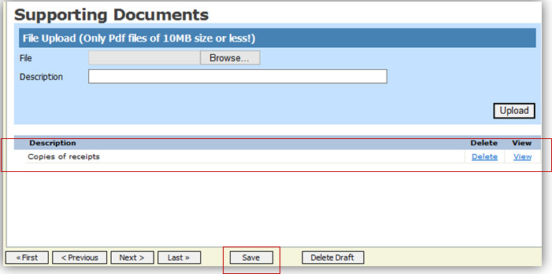
Step
4
Click Save.

Signing and Submitting to Court

When you have added all voucher entries, you are ready to sign and submit your voucher to the court.

Click the Confirmation tab or click Last on the progress bar.
Step
1

The Confirmation screen appears which reflects all entries from the previous screens.
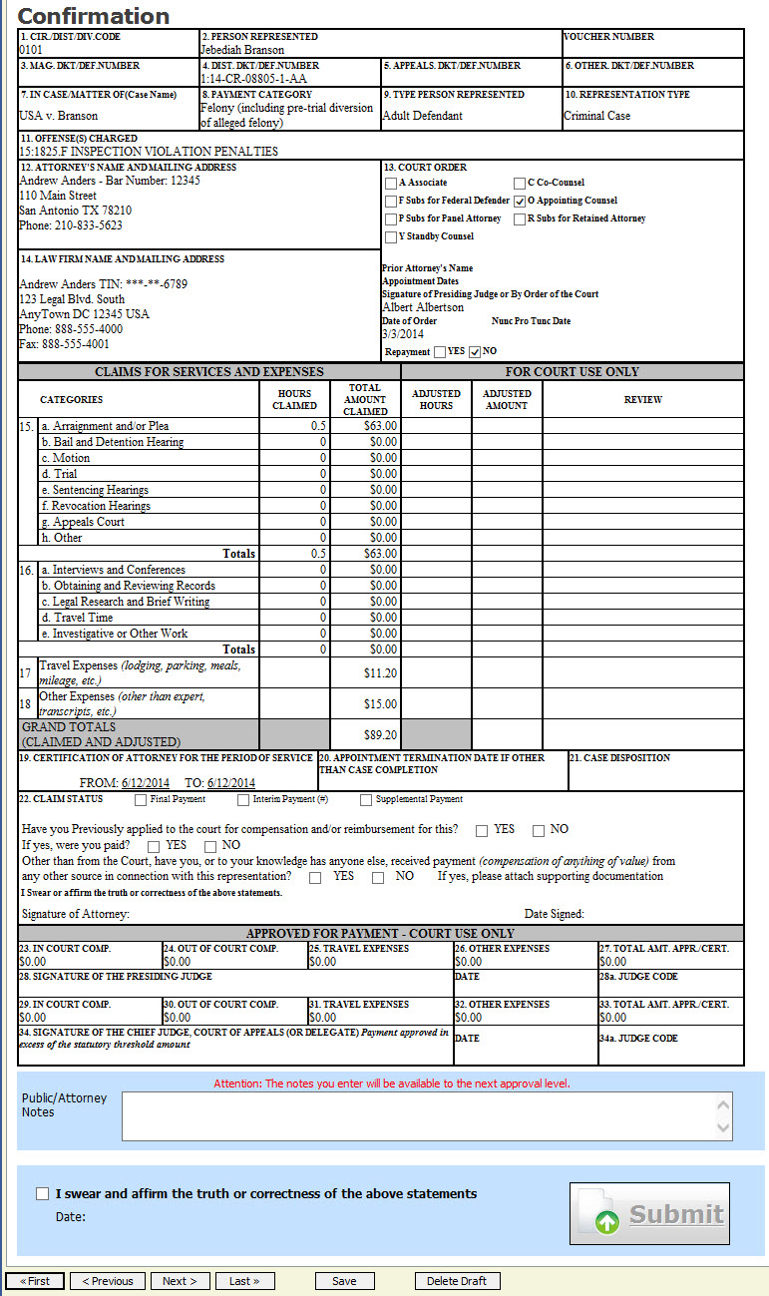

Signing and Submitting to Court (cont’d)

Verify the information is correct.
Step
2

Scroll to the bottom of the screen.
Step
3

Note:
You may include any information to the Court in the Public/Attorney Notes section.
Select the check box to swear and affirm to the accuracy of the voucher. The voucher will automatically be time stamped.
Step
4

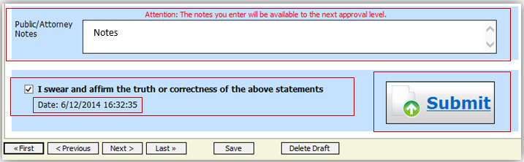

Click Submit to send to the court.
Step
5

A confirmation screen will appear indicating the previous action was successful and the voucher has been submitted for payment.
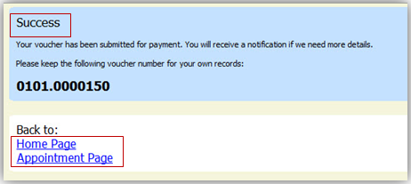
Step
6
Click Home Page to return to the home page. Click Appointment Page if you wish to create an additional document for this appointment.

Signing and Submitting to Court (cont’d)

The active voucher is removed from the My Active Documents folder and now appears in the My Submitted Documents section.

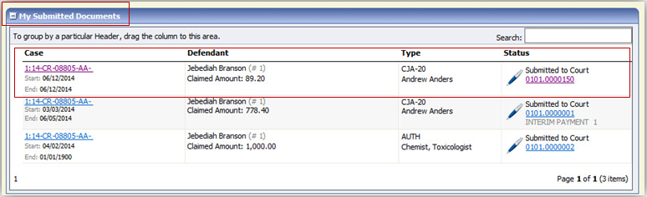

Notes:
- If a voucher is rejected by the court, it will reappear in the My Documents section and will be highlighted in gold.
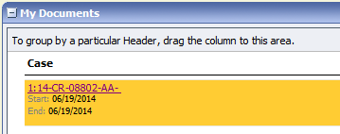
- An email message generated by the system will be sent explaining what corrections need to be made.

CJA-20 Quick Review Panel

When entering time and expenses in a CJA-20 voucher, the attorney may monitor the voucher totals using the quick review panel on the left side of the screen.

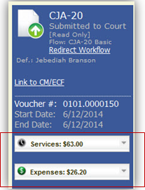
- The Services and Expenses will tally as entries are entered into the voucher.

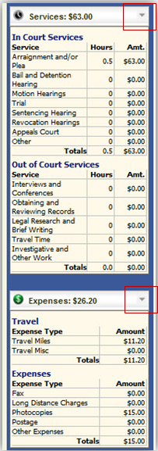
- Expand the item by clicking the down arrow ( ) to reveal specifics.

Reports and Case Management

At the start of a case, it may be difficult for counsel or the court to know whether a case has the potential to exceed the statutory maximum allowed for representation.

Therefore, attorneys are encouraged to monitor the status of funds, attorney hours as well as expert services, by reviewing the reports provided in the CJA eVoucher program. Items to remember:
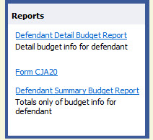
- Viewable reports appear on the left review panel.
- Each panel, depending upon which document you are
viewing, can have different reports available.
- Each report can have a short description of the
information received when viewing that report.
- The two main reports are the Defendant Detail
Budget Report and the Defendant Summary
Budget Report.

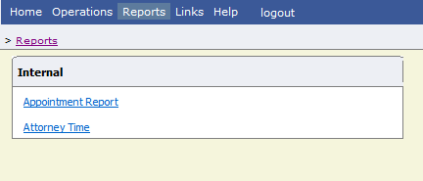
Other accessible reports can be found on the menu bar.

Defendant Detailed Budget Report

This report will reflect the total amount authorized for this representation, any excess payment allowed, the vouchers submitted against those authorizations, and the remaining balances.

The report will provide the information in two sections: Attorney appointment and authorized expert service.

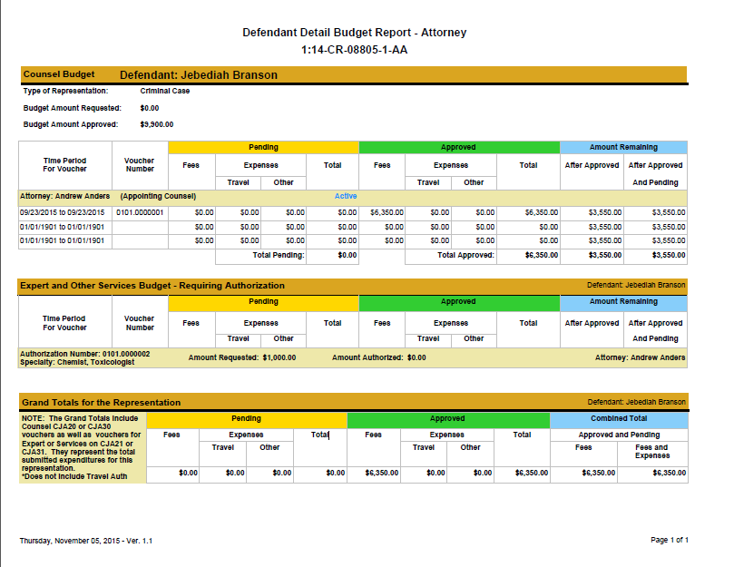

Defendant Summary Report

This report contains the same information as the Detailed Report without the individual voucher data.

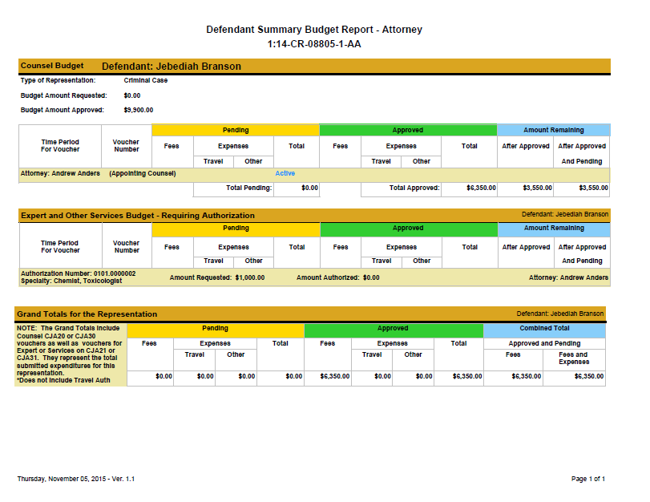

Creating a CJA-21 Voucher
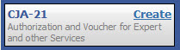
From the Appointment page click Create from the CJA 21 Voucher template.
Step
1
The voucher opens to the Basic Info page.
Note:
There is NOT AN AUTOSAVE function on this program. You must click Save periodically to save your work.

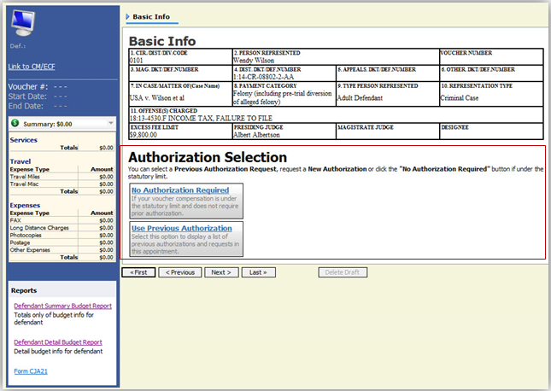

When submitting a CJA-21 voucher, you’ll have two options from which to choose under Authorization Selection.
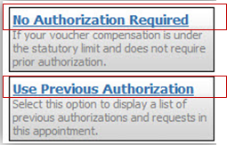
If the request does not require advance authorization, click No Authorization Required.

Step
2
If you have a previously approved authorization, click Use Previous Authorization.

Creating a CJA-21 Voucher (cont’d)

If you click Use Previous Authorization a list of Existing Requests for Authorization will appear.
Select the authorization you wish to use. The selected authorization will highlight in yellow. You will not be able to continue until it is highlighted.

Step
3
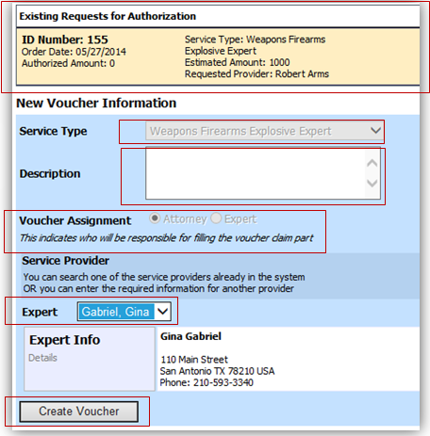

The service type will roll over from the authorization selected. If no authorization is being used, use the Service Type drop-down list to select the service type.

Step
4

Enter a description of the service to be provided in the Description field.

Step
5

From the Expert drop-down list, select the expert.
If the expert you select is not authorized to use eVoucher, the Voucher Assignment field will remain locked indicating the attorney will be responsible for filling the voucher claim part.

If the expert you selected is authorized to enter their own voucher information, the Voucher Assignment button will unlock for you indicating the expert will be responsible for filling in the voucher claim part.

Step
6

Note:
Only experts registered with the service type selected will appear in the drop-down list. If you wish to submit a person for approval, steps on how to add an expert are on page 36.

Creating a CJA-21 Voucher (cont’d)

Step
7
Click Create Voucher.

Notes:
- If all information is not entered you cannot advance to the next screen.
- If the Expert you selected is authorized to use eVoucher you are done at this point and you may click Home or logout.
- If the Expert you selected is not authorized to use eVoucher you will file the voucher on behalf of the expert. The voucher will appear in the “My Active Documents” section as submitted to attorney. You will perform the second level of approval/submission by clicking on the voucher, navigating to the “Confirmation” page and approving the voucher. The voucher will then move to the “My Submitted Documents” section. Outlined steps are on pages 36-39.

Creating a CJA-21 Voucher (cont’d)

If you wish to submit a person as an expert, follow steps 3 through 5 on page 34.
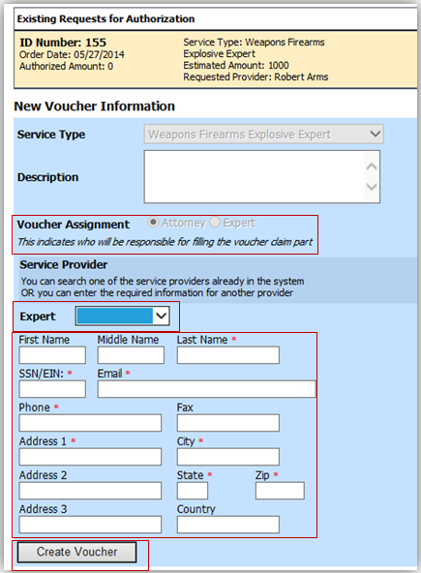
From the Expert drop-down list, select the empty (null) value. Voucher Assignment should be on the Attorney option.

Step
6

Fill in all required information on the person you wish to submit for approval.

Step
7

Click Create Voucher.

Step
8

Note:
- The person you submitted will go through an approval process. Once that person has been approved, an email will be sent to you.
- You’ll now be able to select the person from the Expert drop-down list and all their information will automatically populate.

Creating a CJA-21 Voucher (cont’d)

After Create Voucher has been selected, you’ll proceed with similar steps mentioned on the CJA 20 Voucher adding Services, Expenses, Claim Status, and Documents.

Note:
If you have submitted the voucher for the expert, you’ll need to approve the voucher twice, once while sending it for the expert, and a second time after it appears in the My Active Documents section.
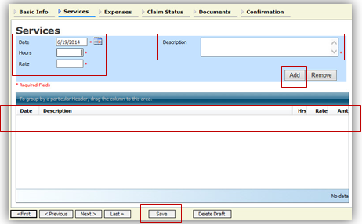
Click the Services tab or click Next on the progress bar.
Step
1

Enter the Date, Hours, Rate, and Description.

Step
2

Click Add.

Step
3

The item will appear at the bottom of the
Services section.

Step
4
Click Save.

Click Add.

Click Save.

Enter the Date, Expense Type, Description and Miles.

Step
3
Step
2
Step
1
Click the Expenses tab or click Next on the progress bar.
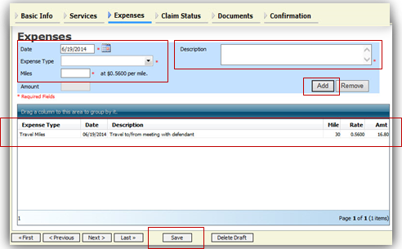

The item will appear at the bottom of the
Step
4
Expense Type section.

Creating a CJA-21 Voucher (cont’d)
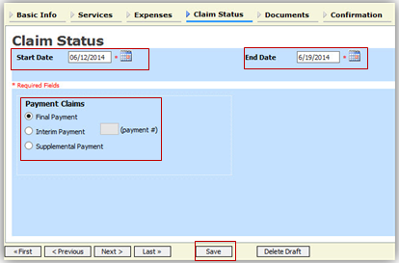
Step
1
Click the Claim Status tab or click Next..

Enter the Start and End Date, making sure to select the earliest date of services and expenses as the Start Date.

Step
2

Step
3
Select an option under the Payment Claims section.
Payment Claims section.

Step
4
Click Save.

Note:
- Final Payment is requested after all services have been completed.
- Interim Payment allows for payment in segments, but each court’s practice may differ. If using this type of payment indicate the number of this request payment.
- After Final Payment number has been submitted, Supplemental Payment may be requested due to a missed or forgotten receipt.

Step
1
Click the Documents tab or click Next..
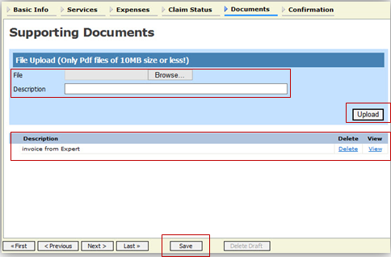
Click Browse to select a PDF file to attach.

Click Upload.

Step
3

Step
2

Note:
All documents must be submitted in PDF format and must be 10 MB or less.

The document will appear in the bottom of the Description section.
Creating a CJA-21 Voucher (cont’d)
Step
4
Click Save.

A confirmation page will appear.
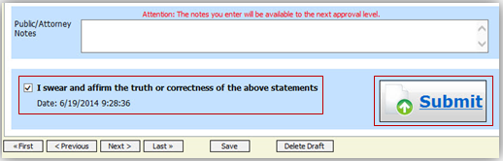
Step
1
Verify all information is correct.

Select the affirmation check box. This will automatically time stamp the voucher.

Step
2
Click Submit.

Step
3

A confirmation screen will appear indicating the previous action was successful and the voucher has been submitted.
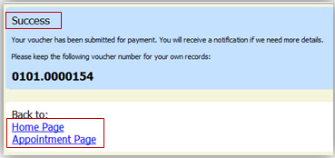
Click Home Page to return to the home page. Click Appointment Page if you wish to create an additional document for this appointment.

Step
4

The case file will appear in the My Active Documents section.
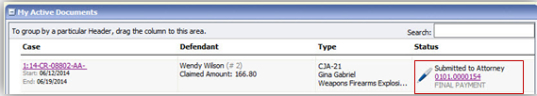
Select the file.

Step
5

Navigate to the Confirmation tab.

Verify all information is correct.
Step
8
Step
6
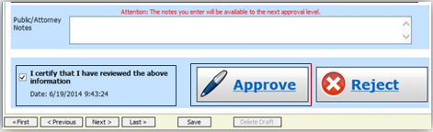

Certify the information by selecting the certification check box. This will automatically time stamp the voucher.

Step
7

Click Approve.

Submitting an Authorization Request for Expert Services

Open the Appointment record.
Step
1

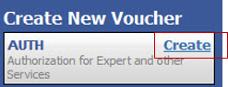
Click Create next to AUTH.
Step
2

The Basic Info screen will open.
Note:
There is NOT AN AUTOSAVE function on this program. You must click Save periodically to save your work.

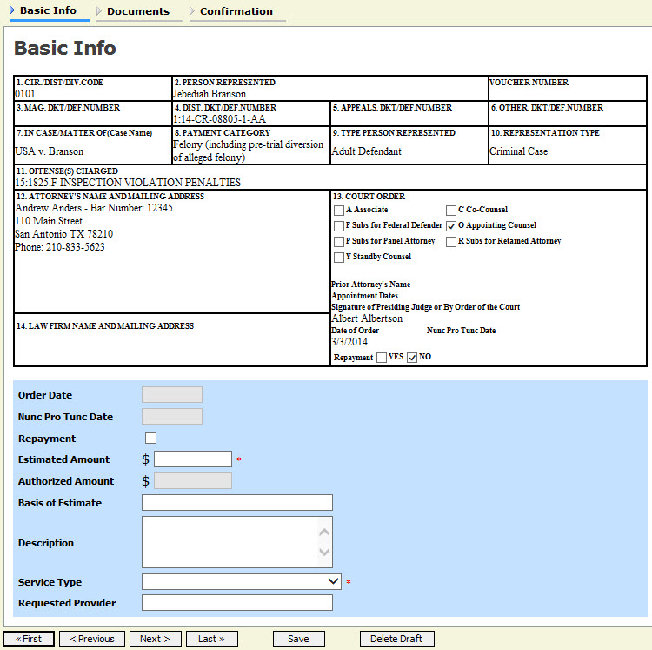

Submitting an Authorization Request for Expert Services (cont’d)

Complete the information in the blue section at the bottom of the screen. This includes the following fields:
- Estimated Amount
- Basis of Estimate
- Service Type drop-down list
- Request Provider drop-down list

- sted StepProvider Step
3

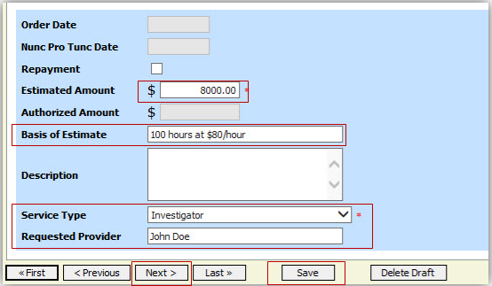

Click Save.
Step
4

Click the Supporting Documents tab or click Next.

Step
5

Submitting an Authorization Request for Expert Services (cont’d)

To add the attachment, click Browse to locate your file.
Step
1

Note:
Documents are limited to PDF files, and must be 10 MB or less.
In the Description field, add a description of the attachment.
Step
2

Click Upload.

Step
3

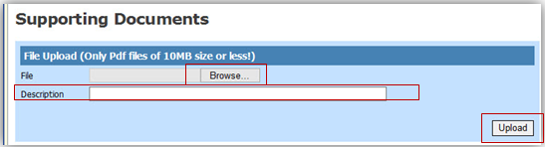

The attachment and description will be uploaded and appear at the bottom of the Description section.

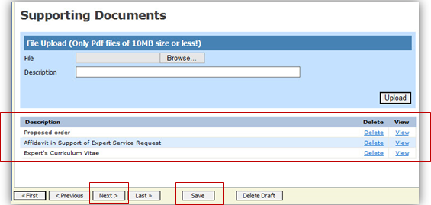
Step
4

Click Save.

Submitting an Authorization Request for Expert Services (cont’d)

Step
5
Click Next.

The Confirmation screen will open.
Select the check box to swear and affirm to the accuracy of the authorization. The authorization will automatically be time stamped.
Note:
You may include any notes to the court in the Public/Attorney Notes section.
Step
6

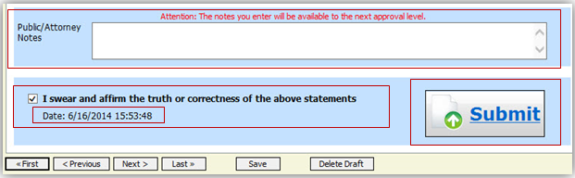
Click Submit to send to the court.
Step
7

A confirmation screen will appear indicating the previous action was successful and the Authorization Request has been submitted.
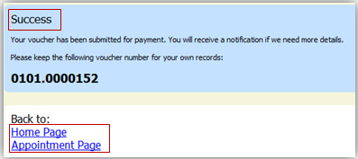

Step
8
Click Home Page to return to the home page. Click Appointment Page if you wish to create additional document for this appointment.

The Authorization Request will now appear in the My Submitted Documents section on the Attorney home page.

Creating an Authorizations for Transcripts (AUTH-24)

Step
1
From the Appointment page, click Create AUTH-24.
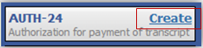

The Authorization opens to the Basic Info page.
Note:
There is NOT AN AUTOSAVE function on this program. You must click Save periodically to save your work.

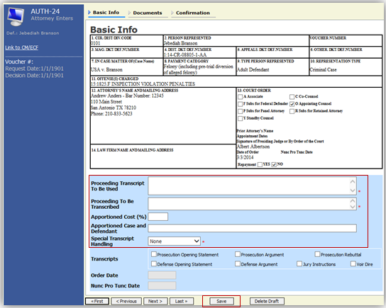

Enter the details for the transcript required on the Basic Info screen.
Step
2

Step
3
Click Save.

Creating an Authorization for AUTH-24 Transcripts (cont’d)
Click Save.

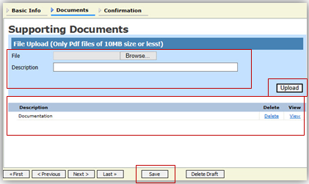
Step
1
Click the Documents tab or click Next.

Step
2
Click Browse to select a PDF file to attach.

Step
3
Click Upload.

Note:
All documents must be submitted in PDF format and must be 10 MB or less.

The Document will appear at the bottom of the Description section.
Step
4
Click Save.

A confirmation page will appear.

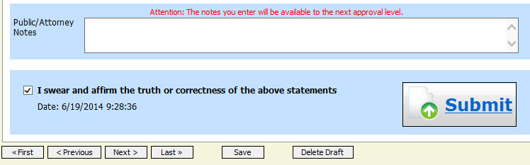
Verify all information is correct.

Step
5

Select the affirmation check box.

Step
6

Click Submit.

Step
7

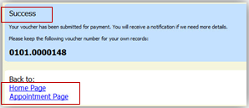
A confirmation screen will appear indicating the previous action was successful and the Authorization Request has been submitted.

Click Home Page to return to the home page. Click Appointment Page if you wish to create additional document for this appointment.

Step
8

The AUTH-24 will now appear in the My Submitted Documents section on the Attorney home page.

Creating a CJA-24 Voucher

After submission and approval of AUTH-24, you can create the CJA-24 voucher for payment.
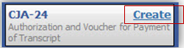
From the Appointment page, click Create next to CJA-24.
Step
1

The Basic Info page will open, showing approved authorizations.

Note:
There is NOT AN AUTOSAVE function on this program. You must click Save periodically to save your work.

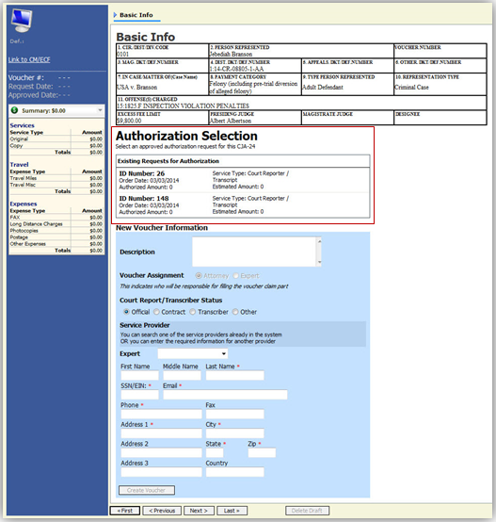
Creating a CJA-24 Voucher (cont’d)
Select the authorization you wish to use. You must click it. This will highlight it in yellow. You will not be able to move forward until it is highlighted.

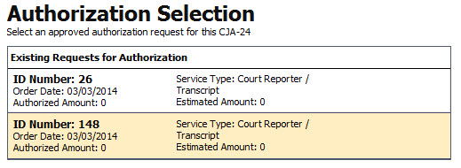
Step
2

Step
3
Click the Voucher Assignment radio button indicating whether you or the transcriptionist will be entering information. .

Note:
You must select whether you, the attorney, or the court reporter will be filling the voucher claim portion.
Step
4
Click the Expert drop-down menu and select the transcriptionist.

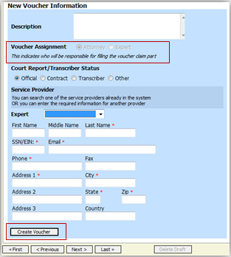
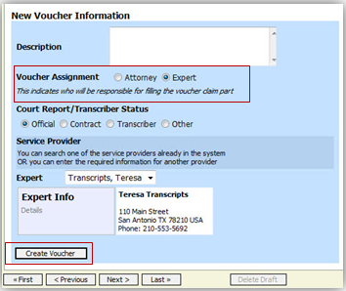

Note:
- If entering a new transcriptionist into the system, select a blank drop-down and enter all required information.
- Selecting a transcriptionist already in the system will automatically populate that expert’s information.
Click Create Voucher.

Step
5

Creating a CJA-24 Voucher (cont’d)

Note:
If Expert has been selected under the Voucher Assignment, the expert will fill out the required expense information and submit the form. The attorney will then approve it and submit to the court.

Click the Services tab or click Next.
Step
1
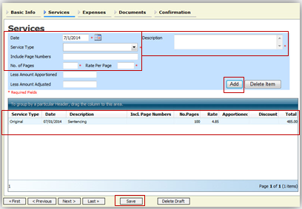

Enter the Date, Service Type, No. of Pages, Rate, and Description.

Step
2

Note:
You’ll have two options to choose from under Service Type: Original or Copy. The rate should vary between the two choices.

Click Add.

Step
3

The item will appear in the bottom of the Service Type section.
Step
4
Click Save.

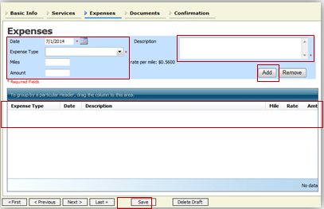
Click the Expenses tab or click Next.
Click Add.

Enter the Date, Expense Type, and Description.

Step
3
Step
2
Step
1

The item will appear below in the Expense section.
Click Save.

Step
4
Creating a CJA-24 Voucher (cont’d)
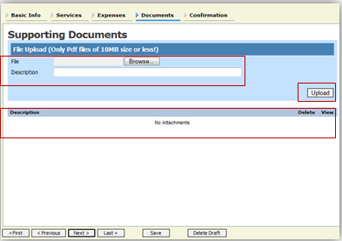
Step
1
Click the Documents tab or click Next.

Click Browse to select a PDF file to attach.

Step
2

Note:
All documents must be submitted in PDF format, and must be 10 MB or less.

Step
3
Click Upload.

The document will appear at the bottom of the Description section.
Click Save.

Step
4

A confirmation page will appear.
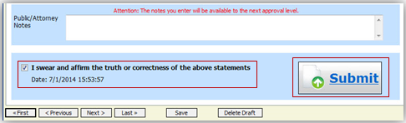
Step
1
Verify all information is correct.

Select the affirmation check box. This will automatically time stamp the voucher.

Step
2
Click Submit.

Step
3

A confirmation screen will appear indicating the previous action was successful, and the voucher has been submitted.
Click Home Page to return to the home page. Click Appointment Page if you wish to create an additional document for this appointment.

Step
4

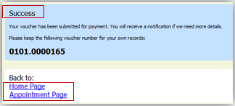

Creating a Travel Voucher
From the Appointment page, click Create next to TRAVEL.
Step
1
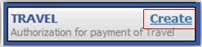
Note:
There is NOT AN AUTOSAVE function on this program. You must click Save periodically to save your work.

The Basic Info screen will open.

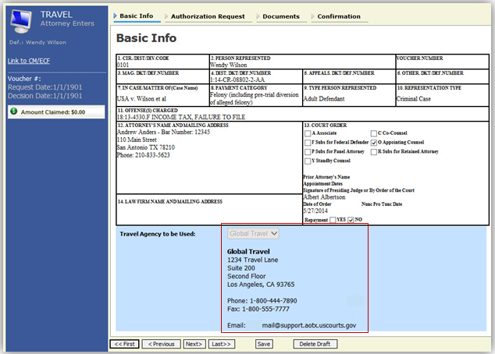

The Travel Agency to be Used section will automatically populate.

Step
2
Click the Authorization Request tab or click Next.

Creating a Travel Voucher (cont’d)
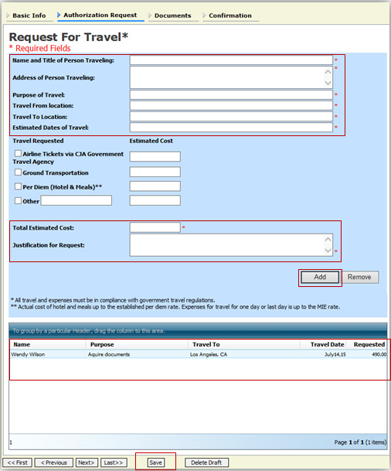
Fill out all required fields marked with a red asterisk.
Step
3

Click Add.
Step
4

The information will appear in the
bottom section.
Click Save.
Step
5

Creating a Travel Voucher (cont’d)

Note:
All documents must be submitted in PDF format, and must be 10 MB or less.
Click Browse to select a PDF file to attach.

Step
1
Step
2
Click the Documents tab or click Next.
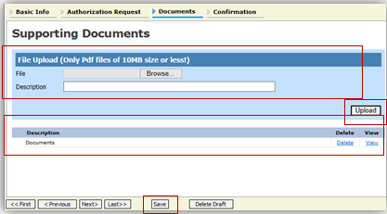

Click Upload.

Step
3

The document will appear at the bottom of the Description section.
Click Save.

Step
4

The Confirmation tab will appear.
Step
1
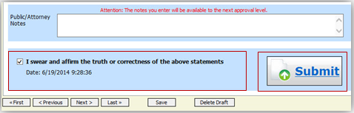
Verify all information is correct.

Select the affirmation check box. This will automatically time stamp the voucher.

Step
2
Click Submit.

Step
3

A confirmation screen will appear indicating the previous action was successful and the voucher has been submitted.
Click Home Page to return to the home page. Click Appointment Page if you wish to create additional document for this appointment.

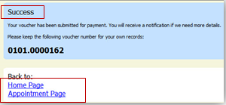
Step
4

The Travel Voucher will now appear in the My Submitted Documents section.

Creating a CJA-26 Voucher

This is a request and justification for expenses outside the statutory limits.
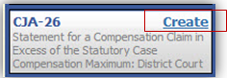
From the Appointment page, click Create next to AUTH-26.
Step
1
The voucher opens to the Basic Info page.
Note:
There is NOT AN AUTOSAVE function on this program. You must click Save periodically to save your work.

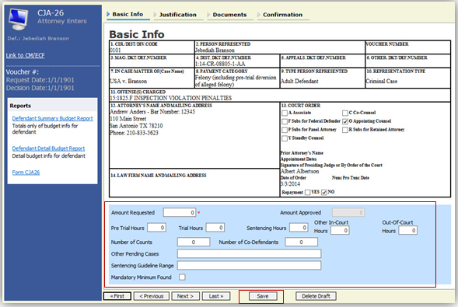

Step
2
Click Save.
Enter the details for information required on the Basic Info screen.
Step
3
Creating a CJA-26 Voucher (cont’d)

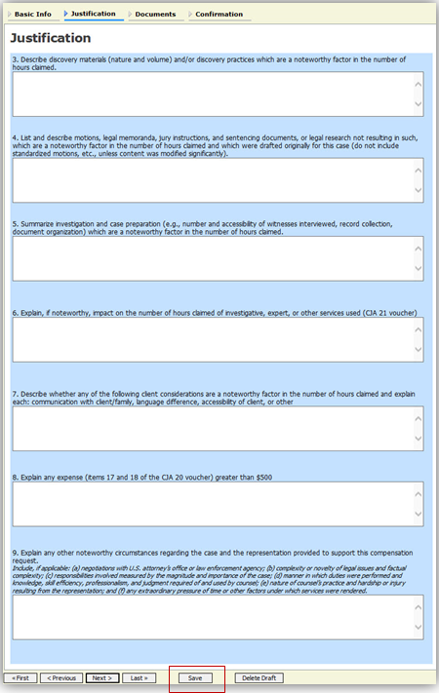
Click the Justification tab or click Next.
Step
1

Step
2
Click Save.

Step
3
Fill out justification text fields.

Creating a CJA-26 Voucher (cont’d)

Click the Documents tab or click Next.
Step
1
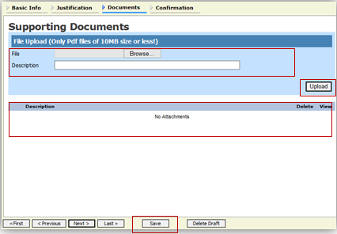

Step
2
Browse to select a PDF file to attach.

Step
3
Click Upload.

Note:
All documents must be submitted in PDF format, and must be 10 MB or less.

The document will appear at the bottom of
the Supporting Documents section.
Step
4
Click Save.

A confirmation page will appear.

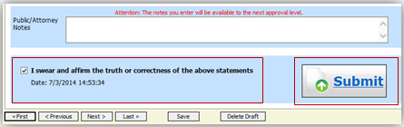
Verify all information is correct.

Step
5

Select the affirmation check box.

Step
6

Click Submit.

Step
7

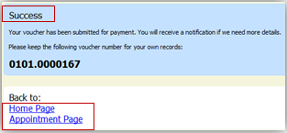
A confirmation screen will appear indicating the previous action was successful and the Authorization Request has been submitted.

Click Home Page to return to the home page. Click Appointment Page if you wish to create additional document for this appointment.

Step
8

The CJA-26 will now appear in the My Submitted Documents section.

