Introduction
The CJA eVoucher System is a web-based solution for submission, monitoring, and management of Criminal Justice Act (CJA) functions. The eVoucher program provides:
- Online submission of vouchers and authorizations by attorneys and experts.
- Line-item auditing of vouchers by judges and court staff.
- The ability to attach PDF documentation to vouchers and authorizations.
- Automatic email notification to attorney on approval or rejection of vouchers.
- Electronic transfer to the Circuit for excess approval.
- Panel management tools and reports for attorney appointments.
- Built-in reporting for budgeting and analysis.

Browser Compatibility
- Windows: Internet Explorer (IE) 8 or newer
- Apple Macintosh: Safari 5.1 or newer
  - Chrome, Mozilla Firefox, and other browsers may not be used with CJA eVoucher

Accessing the CJA eVoucher Program
Your court staff will provide you with information on how to access eVoucher. It is suggested that you bookmark it for easier access. Enter your username and password and click Log In.
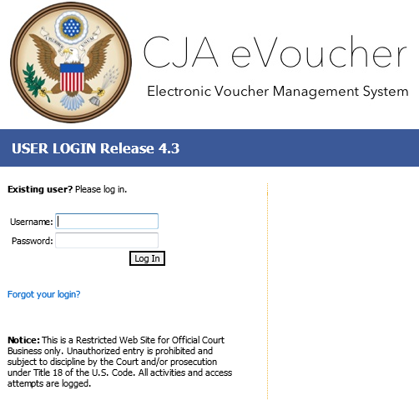

Users will be required to change their passwords within 30 days of the first time they log in to eVoucher. Passwords must be at least eight characters in length and contain:
- One lower-case character
- One upper-case character
- One number
- One special character
If you forget your username or password, click the Forgot your Login hyperlink. Enter your username or email address and click Recover Logon. You will receive an email with instructions on how to reset your password.
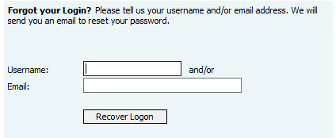

Profile
Your profile contains your login information, your contact information, as well as the billing information that will be used to pay for your services. Your district may allow you to manage and update this information.
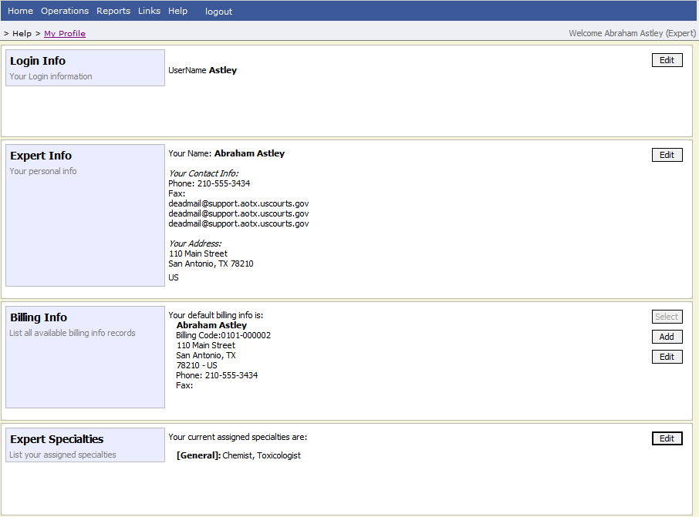

Changing Your Username and Password
You may change both your username and password in your profile. You may access your profile from the home page by clicking the My Profile link to the right of the user profile picture. Or, you may select My Profile from the Help menu.
Click Edit on the right side of the Login Info section.
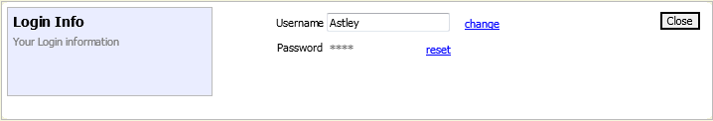
To change your username, type the new username and click Change.
Passwords will expire every 180 days.
To change your password, click Reset. Type the new password and retype it in the confirm field and click Reset. Click Close to exit the Login Info section.

Expert Info
The Expert Info section of the profile contains your designation, name, and contact information. If any information is missing or incorrect, you can change your personal info by clicking Edit to the right of this section of the profile.
Only self-employed Service Providers must enter a social security number in the user profile, Company-employed service providers will need to enter the EIN. Once you have saved your social security number, it becomes read-only and the record is transmitted to CJA 6x. Once your record has been transmitted to CJA6x, any changes to the social security number can only be made by an eVoucher administrator. If you need to make a change, you must contact your court.
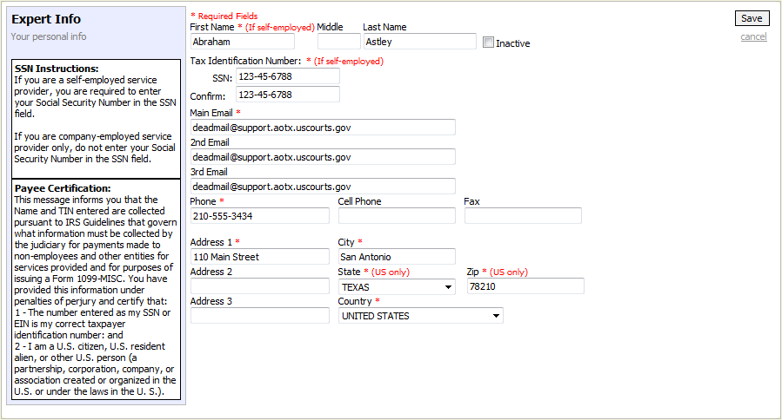

Billing Info
The billing information for your services is contained in the Billing Info section of the profile. If your personal information, address, and phone are correct, you can select the Copy Address from Profile check box. You will not be allowed to submit a voucher in CJA eVoucher without complete billing information. You may edit the billing info by clicking Edit to the far right of the Billing Info section of the profile.
Company-employed service providers are required to enter their name, email information, company’s EIN, name, and payment address information in the billing information section of the user profile. This information is used to establish the company’s record in CJA 6x.
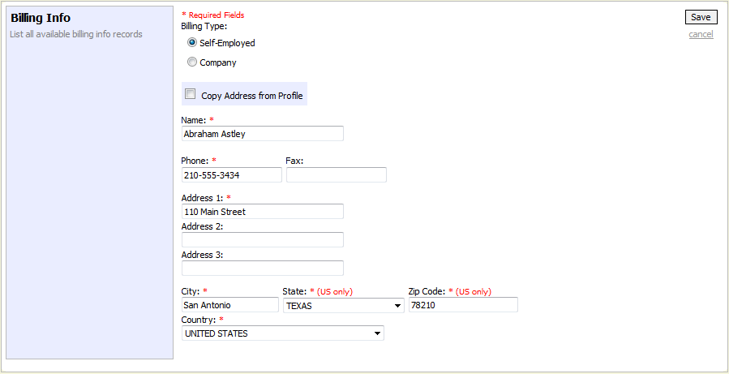
You may add additional billing records by clicking Add. You, or the attorney for whom you are providing services, must choose the billing information you wish to use when creating vouchers or authorizations.
Payments cannot be made if the social security number or EIN is missing from your profile. This is a requirement of the payment system with which eVoucher is interfacing.
The Billing Info section has added Billing Type radio buttons that include:
- Self-Employed - used when payments are made to the expert’s social security number.
- Company - used when payments are made to a firm’s EIN number.
Validations have been added to billing information to ensure the data is in the proper format to be sent to the payment system. If the data is not in the proper format, payments cannot be made. The system will alert you if there are problems with your billing information data. You will need to fix those problems before payments can be made. We ask that you access your profile and verify your social security number, add your social security number if it is not there (unless you are acting only as an associate on the system) and verify your billing information. Please do this as soon as possible so there will not be an interruption in your payments.
Please note that you will not be able to change your social security number or your EIN once it has been synced with the interface. Only the CJA6XAdmin user will have rights to change social security numbers. Also, remember to add new or additional billing records if your billing information changes. Do not edit the existing record.

Expert Specialties
The Expert Specialties section will list any specialties for which you are approved for eVoucher billing. If you are selected from the approved experts list, when vouchers or authorizations for service providers are created in eVoucher, the selection of your specialty will populate your name and billing information (with social security number/EIN masked). That specialty will also be checked on any of the CJA forms (CJA-21, CJA-24, or CJA-31) created in eVoucher.
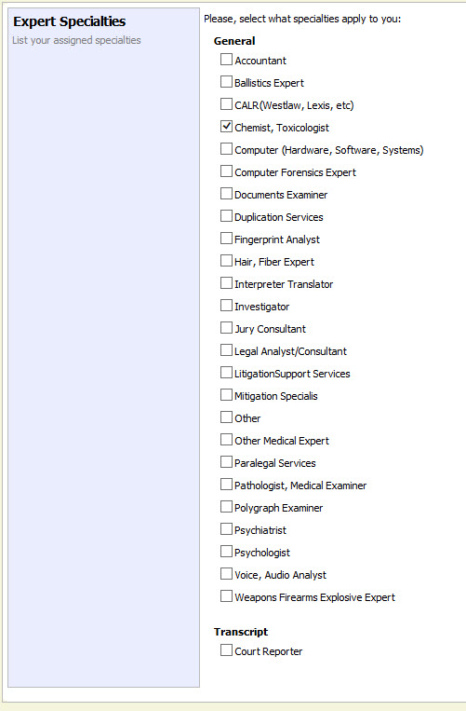

Home Page and Navigation (menu)
The home page provides access to information about your cases and billing information which you submit, or the billing information the attorney submitted on your behalf.
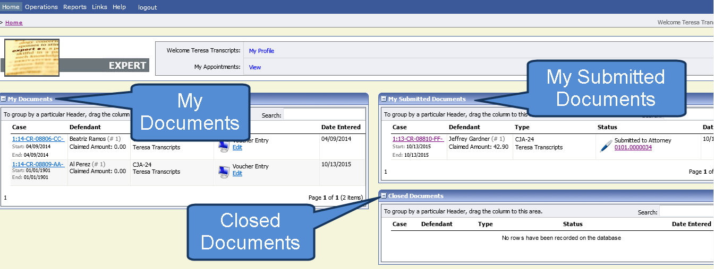

My Documents
The My Documents folder contains vouchers which have been created by you or for you by the attorney. They have not yet been submitted to the court for processing.

My Submitted Documents
The My Submitted Documents folder contains documents which have been submitted to the court for processing.

Closed Documents
The Closed Documents folder contains documents which have been completely processed.

The eVoucher menu
Menu Bar Items
Home | The eVoucher home page
Operations | Appointments you have been assigned
Reports | Selected reports you may run on your appointments
Links | Hyperlinks to CJA resources: forms, guides, publications, etc.
Help | Provides:  - Another link to your Profile  - “Contact Us” e-mail  - Privacy Notice
Logout | Logs user off the eVoucher program

Expert v. Expert Enter
CJA eVoucher allows two designations for experts to complete the voucher: Expert and Expert Enter. When the service provider logs in, he or she will see a list of all of his or her documents on the home page. The Expert role will allow the service provider to log in to eVoucher, view any documents the attorney is creating on his or her behalf, verify the information is correct, and run reports or copies of the CJA-21 or CJA-31.
The Expert Enter role allows the expert to complete his or her voucher after the attorney has created it. If the attorney selects an expert who has Expert Enter privileges, he or she will be able to choose if the attorney or the expert will complete the voucher. The expert can then enter the correct information and submit the voucher back to the attorney for approval.

CJA-21/31 Entry
The attorney will create the CJA-21 or CJA-31 voucher. If the expert selected is authorized to use eVoucher (Expert Enter rights), the attorney can choose to let the expert enter the services and expenses. The attorney should notify the service provider that the voucher has been created and is awaiting completion by the provider.
Log in to the eVoucher application. The voucher should appear in your My Documents folder on your home page.
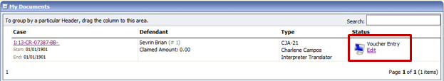
To enter your fees and expenses, click the Edit hyperlink under the Status column.
The Voucher will open to the Basic Info tab screen. The left panel will display a running summary of the services and expenses as they are entered and saved.
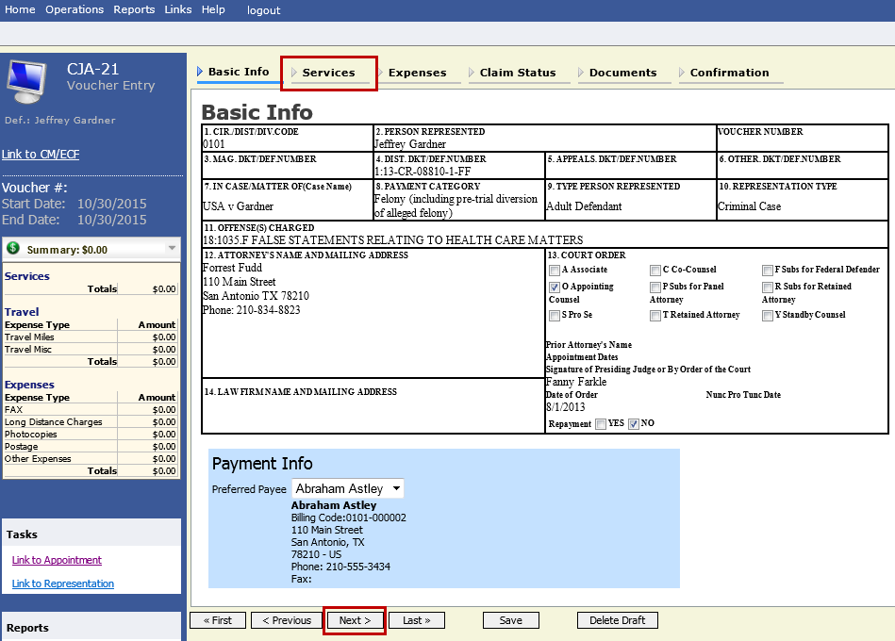
To enter your service fees and expenses, from the Basic Info screen, click the Services tab at the top of screen or click Next at the bottom of the screen.
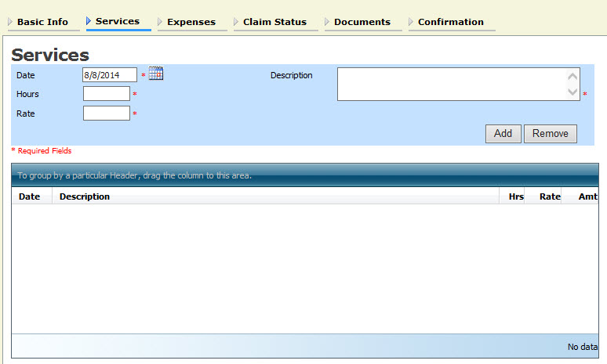
Required fields are marked with a red asterisk. Enter the date of the service, number of hours billed and the rate. A description of the service provided is required. Click Add.
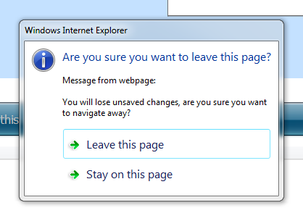
You may continue to add additional entries until you have entered all of your service dates. There is no autosave feature in eVoucher – make sure to click Save after every few additions. You will be prompted to save if you try to navigate to another area within eVoucher.

To enter charges for any additional expenses, click the Expenses tab at the top of the screen or click Next at the bottom of the screen.
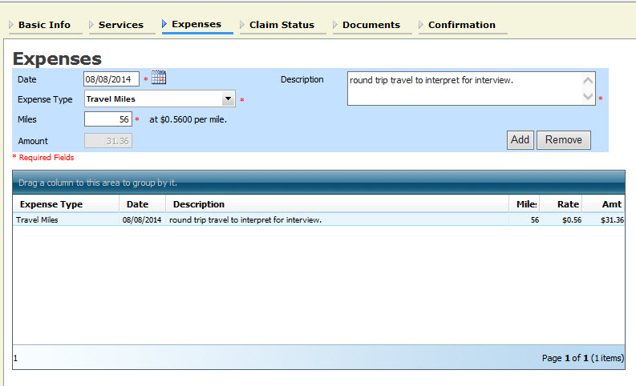
Enter expenses and click Add. Be sure to save your items.
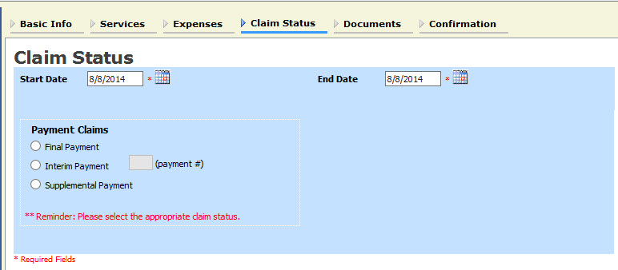
The Claim Status tab will include the date range of your services. The dates default to the day of the creation of the voucher. Ensure that the date range covers the days for which you are billing services and expenses.
Under Payment Claims, make a payment selection. Final payment indicates you will not be billing more on this particular appointment. Interim payments must be OK’d by the court but may be applicable for those involved in long cases. Supplemental payments cover forgotten charges discovered after final payment has been requested.
Navigate to the Documents tab and attach any receipts, invoices, or documents as PDF documents. Label and describe the attachment in the description field and click Upload to attach the PDF documents.
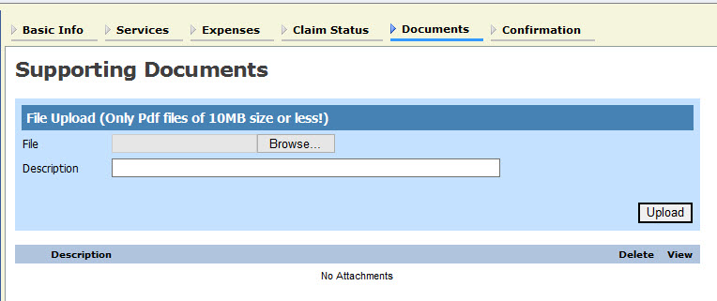
When you have entered all expenses and documents and are ready to submit the voucher, advance to the Confirmation tab. You will be able to review the summary of the voucher and can add any notes which will be available for the attorney and the court staff auditing the voucher.
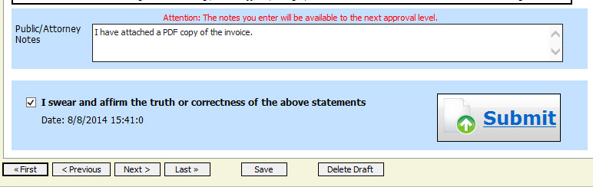
To submit the voucher, select the “I swear and affirm…” check box. This action will also date and time stamp the submission. The Submit button will become active. Click Submit to move the voucher forward to the attorney who must review your voucher before submitting it to the court.

Returned Vouchers
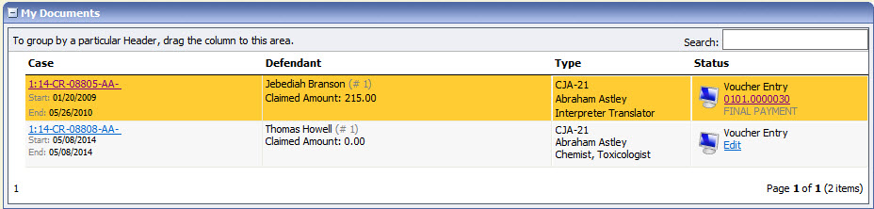
Should there be any issue with your voucher, the attorney may return the voucher to you for correction or additional documentation. Any voucher returned to you will appear with a gold-yellow background. Often the return of the voucher will be accompanied by an email explaining the circumstances. Additionally, you can examine the attorney notes on the Confirmation page to find additional direction.

Printing a Form CJA21
Should you wish to print a copy of your submission, from the left-hand panel, click the Form CJA21 link to print a standard version of the voucher.
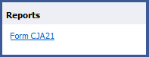
Any reports the expert may have access to will be displayed in the Reports section. Click on the Reports menu item to see which reports are accessible.
