# Linking an Authorization to a CJA-21 Voucher

After your authorization has been approved by the judge, the authorization will appear in your **Closed Vouchers** panel. You may click the voucher number hyperlink to view the voucher if desired.

Step

**Select your appointment.**

To create the CJA-21 Voucher and link it to the authorization, click the defendant case number hyperlink in the **Appointments** panel.

Figure 1: Home Page – Appointment List

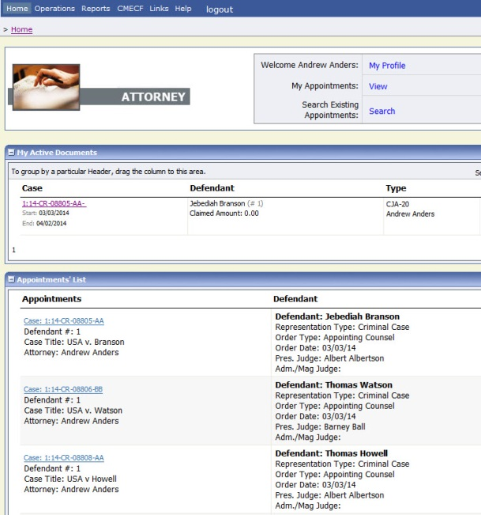

Step

**Create CJA-21.**

On the **Appointment** screen, click the **Create CJA-21** link on the left panel.

Figure 2: Appointment Info

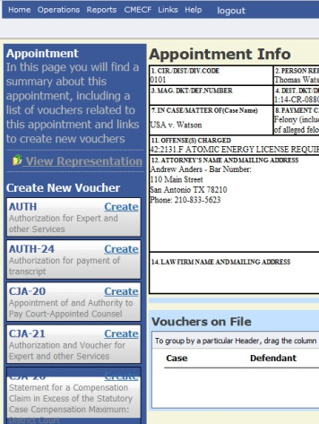

Step

**Authorization Selection**

The **Basic Info** screen will give you the options of **No Authorization Required** or **Use Previous Authorization.** Click **Use Previous Authorization**.

Figure 3: Authorization Selection



## Notes:

* The system will search and display any existing requests for authorization.

Step

**Select Authorization.**

You must click the authorization listed and it will change color to yellow.

Figure 4: Authorization Selection

The application will automatically pull up existing requests for authorization, but you must click it and have it turn golden yellow before you will be able to fill in the new voucher information.



Step

**Fill in the New Voucher Information**

You may search for an existing expert or enter the information for another provider.

Figure 5: New Voucher Information

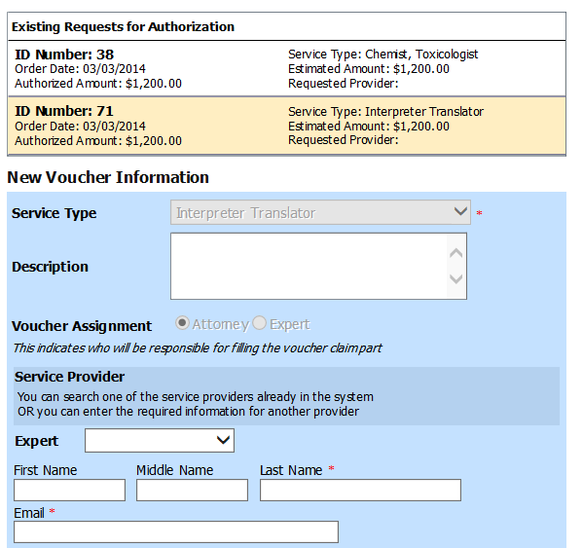

## Notes:

* If the Service Providers or Experts have rights to enter their own expenses, the radio button selection for **Voucher Assignment** will become active, and you will choose if you or the expert will be entering the service fees on the voucher.
* All CJA-21 Vouchers, whether created and submitted by you or by the expert, will then move back to your **Home** page in the **My Service Providers’ Voucher** folder. You must “sign” the completed CJA-21 again to submit it to the court for processing.