How to Create a New CJA 20 Voucher
On your Home page, locate the appointment in the Appointments’ List. Click the case hyperlink.

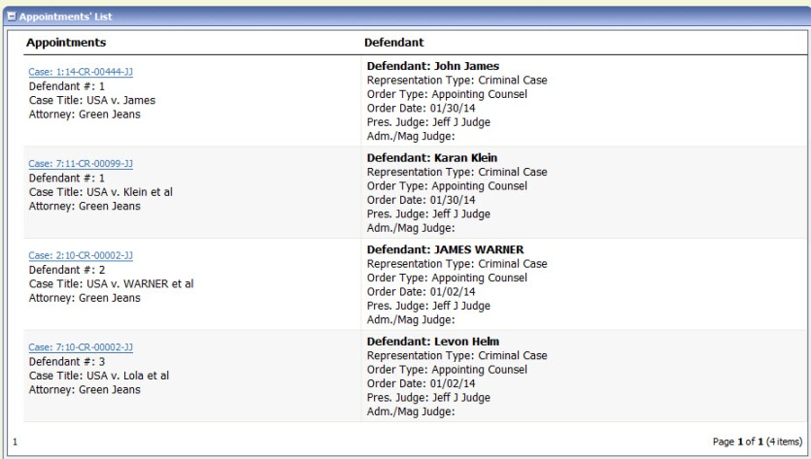
The Appointment Info displays and you will see any vouchers that have been created for this appointment.
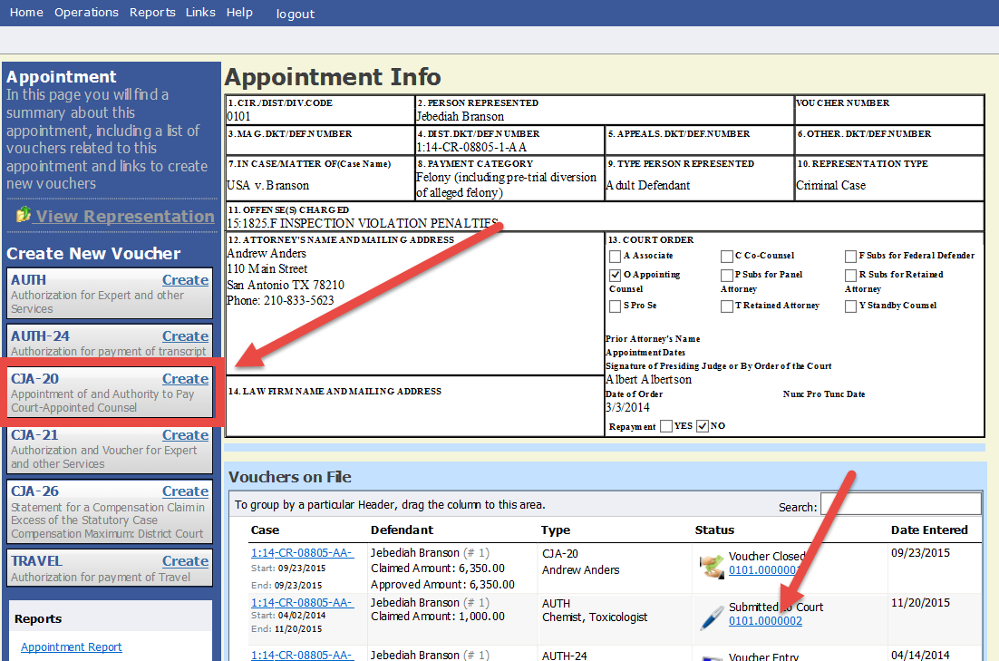
Click the CJA-20 Create button on the left-side menu unless you see an existing CJA-20 voucher in the Vouchers on File that you have already created. (If you find an existing voucher, click the Edit hyperlink to view the document.)

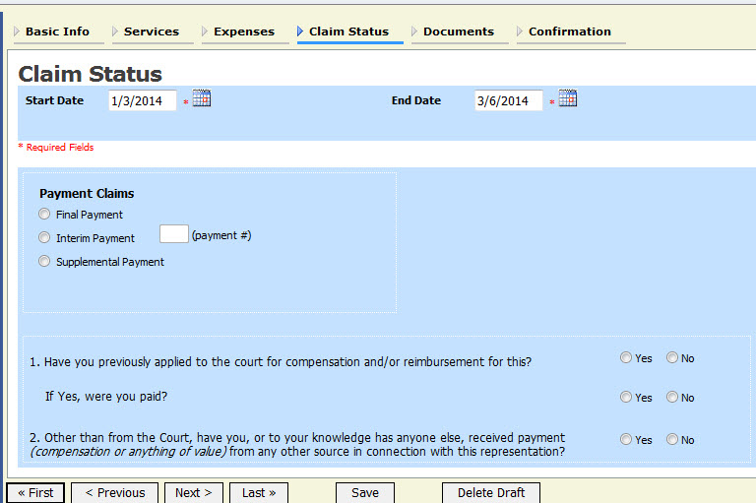
Advance to the Claim Status tab and set the Claim Start Date to the first day of services or expenses billed (It will default to the current date.) Enter your expenses in the Services and Expenses tabs and save your work. You may continue to add items and edit the voucher until you are ready to submit the claim to the court.

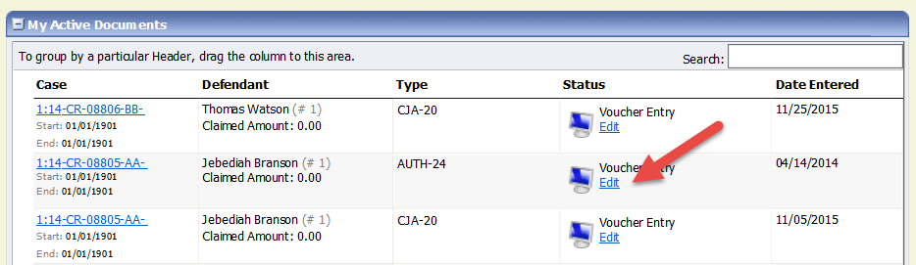
If you save your voucher and do not submit it to the court, you will find your voucher in the My Active Documents folder on the top left of your Home page. To continue working with the voucher, click the Edit hyperlink in the Status column.

Helpful Hint: Sort your Expenses and Services by date to get the correct Start Date.
You can quickly sort your services and expenses by date to find the start date for your voucher. Navigate to the Services tab. Drag the Date column header up to the blue group by area. The services entry will be grouped and sorted by date. Repeat the grouping with the Expenses tab.
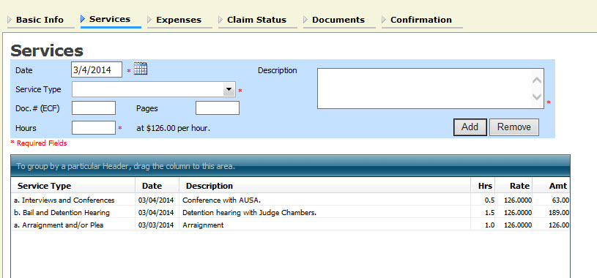
After grouping by Date:
