First Login to CJA eVoucher
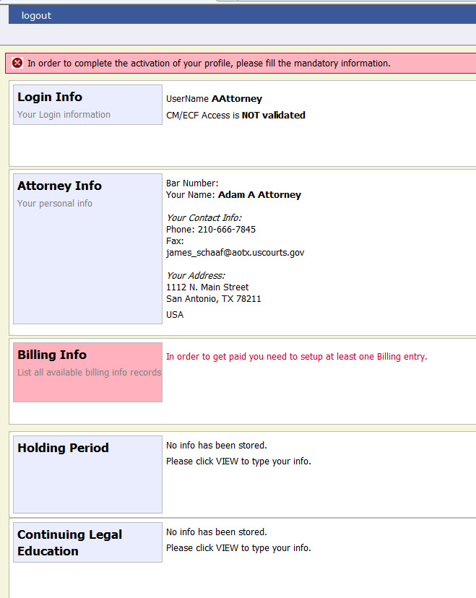
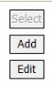
The first time you log in to CJA eVoucher, a screen may appear requesting you to complete your profile information, especially your billing information. Click Add to the right of the Billing Info section.. When you have completed any missing information, log out and log in again. You should go directly to your Home page. If the profile error page appears again with a new login attempt, check each section for missing information such as phone numbers, Tax ID, etc.

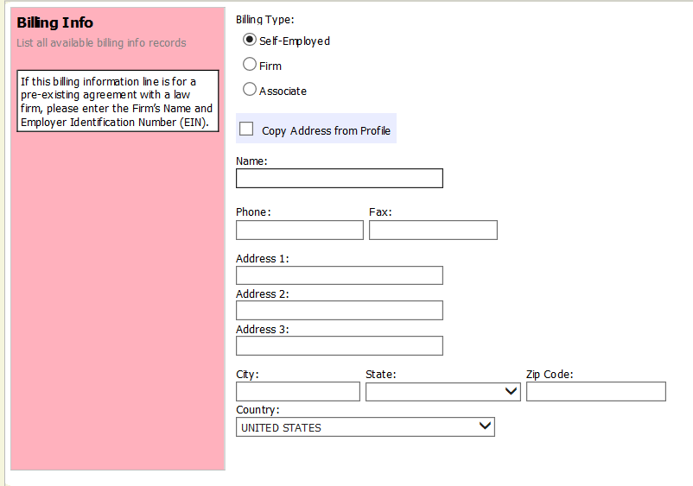

Users will be required to change their passwords within 30 days of the first time they log in to eVoucher. Passwords must be at least eight characters in length and contain:
- One lowercase character
- One uppercase character
- One number
- One special character
Users are required to periodically change their passwords..

